clc;
clear;
% --------------------------
% Parameters
% --------------------------
N = 64; % Number of subcarriers
CP_len = 16; % Cyclic prefix length
num_symbols = 100; % Number of OFDM symbols per SNR
M = 4; % QPSK (2 bits per symbol)
SNR_dB_range = 0:2:20; % SNR range in dB for BER plot
num_bits_per_symbol = log2(M);
num_total_bits = num_symbols * N * num_bits_per_symbol;

BER = zeros(length(SNR_dB_range), 1); % Initialize BER array

% --------------------------
% Start BER vs. SNR Simulation
% --------------------------
for idx = 1:length(SNR_dB_range)
snr_db = SNR_dB_range(idx);

% --------------------------------------
% Transmitter: Generate random data bits
% --------------------------------------
bits = randi([0 1], num_total_bits, 1);

% --------------------------------------
% QPSK Modulation (manual)
% --------------------------------------
symbols = zeros(length(bits)/2, 1);
for i = 1:2:length(bits)
b1 = bits(i);
b2 = bits(i+1);

% QPSK mapping: Gray coding
re = 2 * b1 - 1;
im = 2 * b2 - 1;

symbols((i+1)/2) = (re + 1i * im) / sqrt(2);
end

% --------------------------------------
% OFDM Modulation
% --------------------------------------
ofdm_symbols = reshape(symbols, N, num_symbols); % Reshape to N subcarriers
tx_signal = ifft(ofdm_symbols); % IFFT for OFDM modulation
tx_cp = [tx_signal(end - CP_len + 1:end, :); tx_signal]; % Add cyclic prefix
tx_serial = tx_cp(:); % Serialize

% --------------------------------------
% Add AWGN Noise (manual)
% --------------------------------------
signal_power = mean(abs(tx_serial).^2);
snr_linear = 10^(snr_db / 10);
noise_power = signal_power / snr_linear;
noise = sqrt(noise_power / 2) * (randn(size(tx_serial)) + 1i * randn(size(tx_serial)));
rx_serial = tx_serial + noise;
% --------------------------------------
% OFDM Demodulation
% --------------------------------------
rx_cp = reshape(rx_serial, N + CP_len, num_symbols);
rx_signal = rx_cp(CP_len + 1:end, :);
rx_ofdm_symbols = fft(rx_signal);
rx_symbols = rx_ofdm_symbols(:);
% --------------------------------------
% QPSK Demodulation (manual)
% --------------------------------------
rx_bits = zeros(length(bits), 1);
for k = 1:length(rx_symbols)
re = real(rx_symbols(k));
im = imag(rx_symbols(k));

rx_bits(2*k - 1) = re > 0; % First bit (real part)
rx_bits(2*k) = im > 0; % Second bit (imag part)
end

% --------------------------------------
% BER Calculation
% --------------------------------------
num_errors = sum(bits ~= rx_bits);
BER(idx) = num_errors / length(bits);

disp(['SNR = ' num2str(snr_db) ' dB, BER = ' num2str(BER(idx))]);
end

% --------------------------
% Plot BER vs. SNR
% --------------------------
figure;
semilogy(SNR_dB_range, BER, '-o', 'LineWidth', 2);
grid on;
xlabel('SNR (dB)');
ylabel('Bit Error Rate (BER)');
title('BER vs. SNR for QPSK-OFDM (No External Functions)');
legend('OFDM-QPSK');
Result:
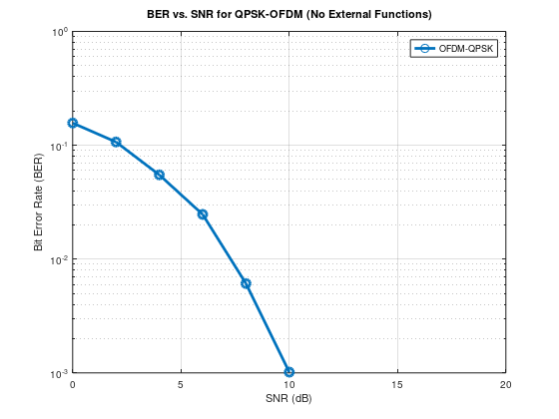
Problem 5: OFDM Transmission over Multipath Fading Channels with Cyclic Prefix in 5G NR
Simulate a 5G NR OFDM system with Cyclic Prefix (CP) and evaluate its performance over multipath fading channels.
- Implement Cyclic Prefix addition and removal.
- Model a multipath fading channel.
- Analyze BER performance under various SNRs and multipath conditions.

Program:
clc;
clear;

% Parameters
num_subcarriers = 64;
num_symbols = 50; % Reduced for faster simulation
cp_len = 16;
SNR_dB_range = 0:5:30;

% Multipath Channel
h = [0.8; 0.5*exp(1j*pi/4); 0.3*exp(1j*pi/3)];

% BER Initialization
BER = zeros(1, length(SNR_dB_range));

% SNR loop
for snr_idx = 1:length(SNR_dB_range)
SNR_dB = SNR_dB_range(snr_idx);
errors = 0;
total_bits = 0;

% Generate bits
num_bits = num_subcarriers * num_symbols * 2; % 2 bits per QPSK symbol
bits = randi([0 1], num_bits, 1);

% QPSK modulation
symbols = zeros(num_subcarriers, num_symbols);
for sym_idx = 1:num_symbols
temp_symbols = zeros(num_subcarriers, 1);
for sc = 1:num_subcarriers
idx = (sym_idx - 1) * num_subcarriers * 2 + (sc - 1) * 2 + 1;
b1 = bits(idx);
b2 = bits(idx + 1);
temp_symbols(sc) = (2*b1 - 1 + 1j*(2*b2 - 1)) / sqrt(2);
end
symbols(:, sym_idx) = temp_symbols;
end

% OFDM Modulation + CP insertion
tx_signal = [];
for i = 1:num_symbols
ifft_data = ifft(symbols(:, i));
ofdm_symbol_cp = [ifft_data(end - cp_len + 1:end); ifft_data]; % Add cyclic prefix
tx_signal = [tx_signal; ofdm_symbol_cp];
end

% Channel convolution
channel_output = conv(tx_signal, h);
channel_output = channel_output(1:length(tx_signal)); % Trim extra samples

% Add AWGN
signal_power = mean(abs(channel_output).^2);
snr_linear = 10^(SNR_dB / 10);
noise_power = signal_power / snr_linear;
noise = sqrt(noise_power / 2) * (randn(size(channel_output)) + 1j * randn(size(channel_output)));

rx_signal = channel_output + noise;

% Receiver: OFDM Demod + CP removal + Equalization
rx_symbols = zeros(num_subcarriers, num_symbols);
index = 0;
for i = 1:num_symbols
start_idx = index + cp_len + 1;
end_idx = index + cp_len + num_subcarriers;

if end_idx > length(rx_signal)
disp('Reached end of rx signal');
break;
end

r = rx_signal(start_idx:end_idx);
index = index + num_subcarriers + cp_len;

rx_ofdm = fft(r);

% Channel frequency response
H = fft([h; zeros(num_subcarriers - length(h), 1)]);

% Zero Forcing Equalizer
eq_ofdm = rx_ofdm ./ H;

rx_symbols(:, i) = eq_ofdm;
end

% Demodulation
rx_bits = zeros(num_bits, 1);
symbol_counter = 0;
for i = 1:num_symbols
for k = 1:num_subcarriers
symbol_counter = symbol_counter + 1;
rx_sym = rx_symbols(k, i);
rx_bits(2*symbol_counter - 1) = real(rx_sym) > 0;
rx_bits(2*symbol_counter) = imag(rx_sym) > 0;
end
end

% BER calculation
bit_errors = sum(bits ~= rx_bits);
BER(snr_idx) = bit_errors / num_bits;

disp(['SNR = ', num2str(SNR_dB), ' dB, BER = ', num2str(BER(snr_idx))]);
end

% Plot BER vs SNR
figure;
semilogy(SNR_dB_range, BER, 'ro-', 'LineWidth', 2);
xlabel('SNR (dB)');
ylabel('Bit Error Rate (BER)');
title('OFDM BER vs SNR over Multipath Channel');
grid on;
legend('QPSK-OFDM');
Result:
SNR = 0 dB, BER = 0.20703
SNR = 5 dB, BER = 0.090781
SNR = 10 dB, BER = 0.026562
SNR = 15 dB, BER = 0.0034375
SNR = 20 dB, BER = 0
SNR = 25 dB, BER = 0
SNR = 30 dB, BER = 0
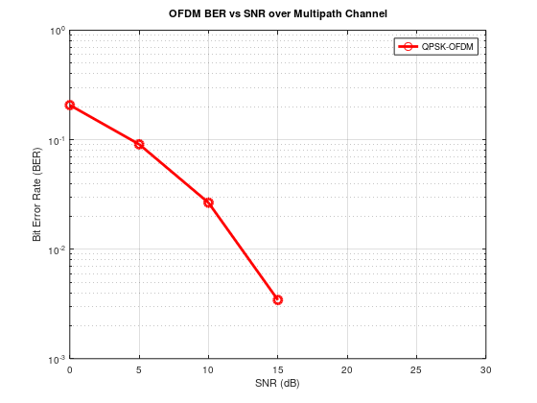

Problem 6: Exploring 5G NR Numerology (Subcarrier Spacing and CP Lengths)
Simulate different 5G NR numerologies by varying subcarrier spacing (SCS) and cyclic prefix lengths. Evaluate their impact on system performance.
- Implement multiple numerology configurations (e.g., 15 kHz, 30 kHz SCS).
- Analyze their effects on bandwidth, latency, and BER.
- Compare the trade-offs between different numerologies.
Program:
clc;
clear;

% Base parameters
f_ref = 15e3; % 15 kHz base subcarrier spacing
numerologies = 0:4; % µ = 0 to 4
fs = 30.72e6; % Sampling rate (for simplicity)

% Arrays to store results
SCS = zeros(size(numerologies));
CP_durations = zeros(size(numerologies));

for i = 1:length(numerologies)
mu = numerologies(i);
SCS(i) = f_ref * 2^mu; % Subcarrier spacing
Nfft = fs / SCS(i);
Ncp = Nfft * 0.07; % Assume CP is 7% of symbol length
CP_durations(i) = Ncp / fs * 1e6; % in microseconds
end

% Plot
figure;
subplot(2,1,1);
stem(numerologies, SCS/1e3, 'LineWidth', 2);
xlabel('Numerology Index (µ)');
ylabel('Subcarrier Spacing (kHz)');
title('5G NR Numerology: Subcarrier Spacing');
grid on;

subplot(2,1,2);
stem(numerologies, CP_durations, 'r', 'LineWidth', 2);
xlabel('Numerology Index (µ)');
ylabel('CP Duration (\mus)');
title('5G NR Numerology: CP Duration');
grid on;
Result:
